Quadcopter Building

Subject:  Related Subjects: | Grade Level(s):  Length of Lesson: | Type: Inquiry / Design / Project  Keywords:

Lesson Overview
Use this section to describe at a high level what the lesson is. Should be no more than 3-4 lines.

Lesson Focus
What is the central question or phenomenon being investigated? What problem are they trying to solve?

Lesson Objective(s) | SWBT get underlying concept of flying by making and flying a quadcopter drone.

Lesson Timing

5 minutes | Introduce the Lesson
30 minutes | ...

Materials | - 1 - complete Flybrix Octocopter Kit:  - 1 - Quadcopter brick set  - 16 - Motor arms in three different styles  - 10 - Quick connect motors  - 32 - Propellers in two sizes and colors  - 1 - Propeller wrench  - 1 – flight board  - 1 - USB data cord  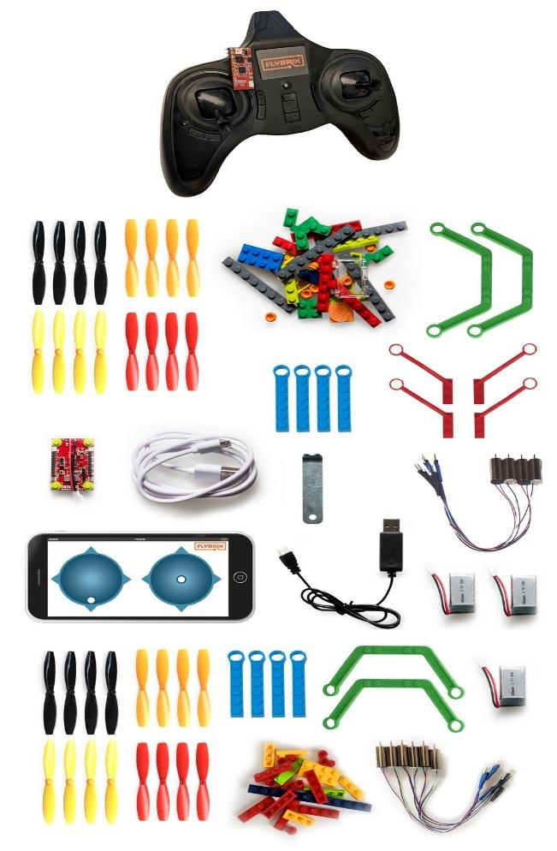  - 2 - 3380mAh high current batteries  - 1 - USB powered battery charger  - 1 - Transmitter (batteries included)  - 1 - Receiver Module
Instructor Prep | - Step 1
Related Resources | - List related lessons/ppts etc available from USC or outside, trusted orgs

Lesson Plan

Introduction
Send an already flying drone inside the classroom. Fly the drone in the classroom for 2/3 mins. Make sure that the drone is out of the reach of the students but well within their sight. Make sure that each student get a good look at the flying drone. The instructor can do that by flying the drone through each row of students. Add drama by customizing the drone, make it complex. Feel free to show any flying tricks. Basically anything that will excite the kids to try it by themselves.
<excited> Hello students and welcome to the xxyyzzz. My name is xxyyzz and I am from xxyyzz. I am currently studying/doing xxyyzz. You can call me xxyyzz.
Before we start tell me how many of you want to do what I just did. <wait for them to show hands or respond> Awesomee !! we are here to make sure you will be able to do that and more. In next two weeks we will be learning and understanding more about drone, we will be making some drones ourselves to understand how they fly. And you know whaat ?? < super excited> we will be playing a lot of games with the drones as well.
Before we start tell me? Ask the students below questions regarding the drone they saw.
How many of you have seen/flown a drone before? <take 1 response. Probe more if time allows>
What was the first thing that you noticed about the drone today? <take 1 response. Probe more if time allows>
How much time do you think building this drone took us? <take 1 response. Probe more if time allows>
What all do you think the drones can be used for? <take 2/3 quick shout out response. Probe more if time allows>
Awesome!! I already like the excitement in the room. My last question is…
When do you think the first drone was made? If you don’t know just take a guess…
Build on the questions to lead to next section.

Okay.. so before we start lets first understand a bit more about drones. What they actually are, where they come from etc.
A Bit of History
It may come as a surprise, but drones are not a recent development. In fact, the concept was experimented with during the second world war. Initially military “drones” were normal aircraft that had been modified to be controlled remotely. These aircraft were normally used as target drones to help train anti-aircraft gunners. One example of this is the Culver PQ-14 [shown below]. These aircraft have more in common with remote-controlled aircraft than drones. I’ll explain why a remote-controlled aircraft is not a drone below.

The Interstate TDR-1 was a little more like a modern drone than the PQ-14. It was capable of carrying weapons and had a camera fitted in the nose to allow it to be flown from further away. Even though the program to develop the TDR “assault drone” was cancelled, it still shows that the idea of using unmanned aircraft for real world missions is hardly a new one.
Interstate TDR-1 on display at Naval Aviation Museum

A definition for a drone
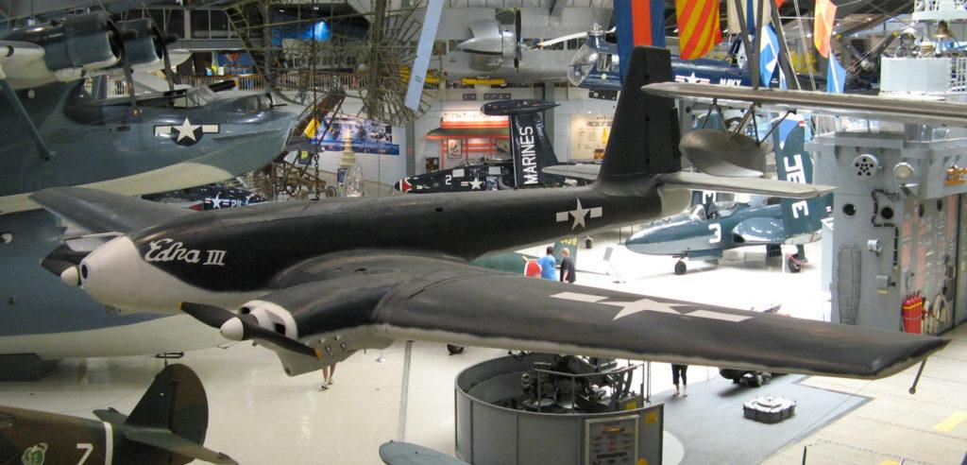
All drone aircraft have two things in common,
- They are all remotely piloted.
- They all have some degree of autonomy (stabilisation).
These are my two requirements to be able to call an aircraft a drone.

Remote controlled aircraft
I’ve referred to remote-controlled (or radio-controlled) aircraft earlier in this post, but how are they defined? Well, when I say a remote-controlled (RC) aircraft, I am referring to a craft that is flown remotely but doesn’t have any onboard control systems. I generally don’t consider this type of aircraft to be a drone because of its lack of autonomy. It is possible to fit off the shelf controllers to remote-control aircraft to make them into autonomous drones however.
This is one area of drone use which can become quite tricky from a legal point of view. It is often difficult to tell the difference between a hobby RC aircraft and a drone. Sometimes the same aircraft will be considered differently purely based on how it is being used. Legislation on this topic can vary widely from country to country and is usually quite complicated, so I won’t journey any deeper into the legality in this post, but Wikipedia does have an article on this subject, for more general information.
A remote-controlled glider in flight

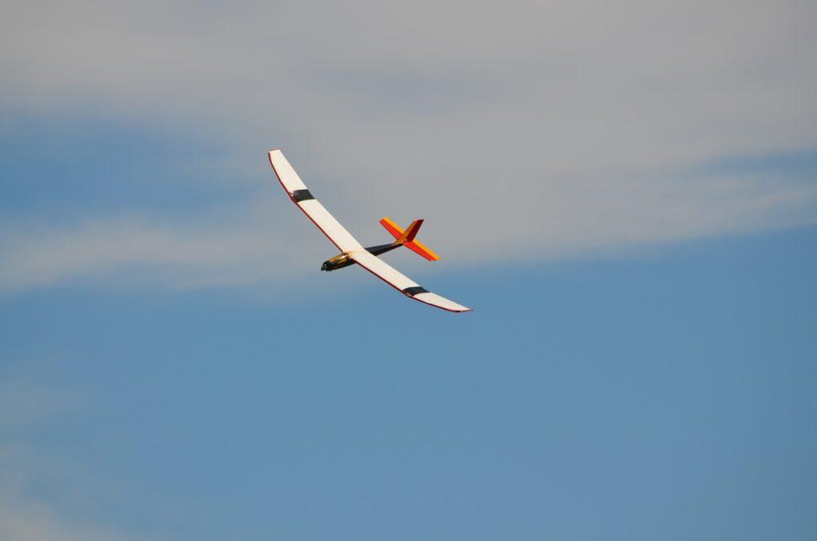

Commercial drones

Recently, several companies have started developing drones specifically for commercial purposes. Often these resemble military UAV’s but have designs more suited for the civilian market. My hope is that these new aircraft can give drones in general, a better reputation with the public.
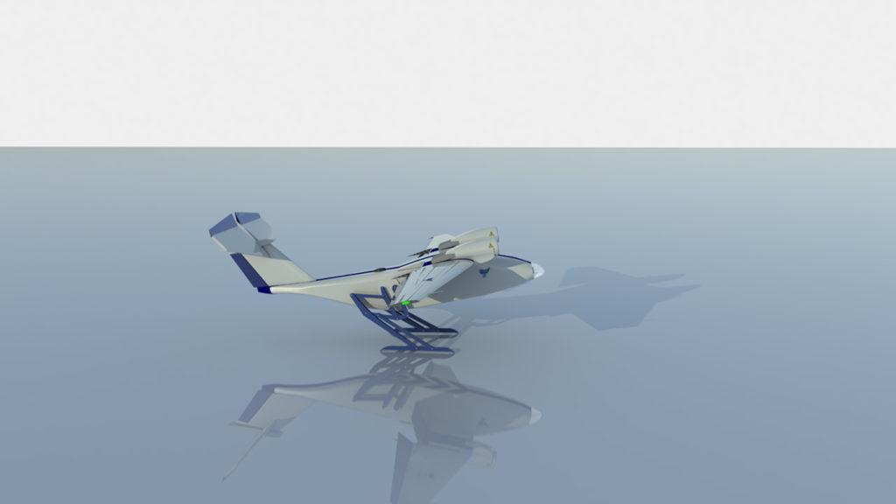
This rise in interest in commercial applications and the advancements in onboard controllers, has allowed us, at Passerine Aircraft, to research and develop a new drone that will allow companies and people to take advantage of the ease of flying usually associated with multi-rotors. Our drone does not require any ground infrastructure and allows for long range and high-speed flight. These attributes are all useful in package delivery and landscape surveying.

The Passerine Sparrow Jumper about to take-off
Finally, to answer my question…
Drones are far more than multi-rotors or military UAV’s. Any remotely piloted aircraft with a flight controller can be a drone. Drones have the potential to take on many forms and many roles and this is why this technology is so exciting!

Multi-rotors
Quadcopters, Hexacopters, Octocopters or any other number-of-rotor craft are what most people think of when someone talks about a drone. These aircraft are very easy to put together and appear to be easy to fly. They have made flying accessible to everyone in a way that fixed-wing aircraft and helicopters couldn’t. Their apparent ease of operation is achieved by using a fairly powerful onboard flight controller, so that they can basically fly themselves. The pilot simply tells them where to go.
Alright kids!! Without further wait let’s jump in. I want one member from each team to collect your kits from me. The parts in the kits are very small and thus I want you all to wait for me to give you next instructions. If you have your kit with you I want you all to keep the kits in front of you and wait for everyone.
Now.. I see everyone has their kits with them… alright !!! lets open them. we will first go through all the parts and their names. Pay close attention because you it is important you know what each part is called. When we will be building the drones later today I will use these names to give you instructions.
Each of you boxes will have a sheet with all the parts in them. I want you all to match the parts, count them and check if you all have everything. One very important thing : please keep all the parts safe and don’t lose them. This is your kit for today and tomorrow and you will need all the parts tomorrow again to make your own drone.

A small quiz among the kids to recall the parts
Alright students, before we actually dive into making our drones I want to check if you know your drone parts!! I want you all to raise your hand and show me the following things from your kit:
- Motor Arms <kids will show motor arms>
- Flight Board<kids will show flight board>
- Batteries<kids will show batteries>
- Propeller<kids will show propellers.>
very good. I wat you to turn your propeller and look for anything written behind it. < Ask one kid to turn around the propeller and read loudly the alphabet written behind it eg A or B>. Is there anyone with a different alphabet. <take one kid answer > so there are two type of propellers A’s and B’s. Do the A’s and B’s look different?? What is different?? <take one or two answers> yes they are different and there is a reason for it. We will learn more about it when we are building but as of now I want you to keep this in mind
- RC remote controller <kids will show remote controller>
- Minifig and windshield<kids will show minifig ad windshield>
Awesome everyone!!! You all are doing great!! Now that I am confident you all are ready for what is coming next….. THE ACTUAL DRONE MAKING!!! <make a big deal out of it> lets just do it !!
Let’s put our batteries on charge before we start
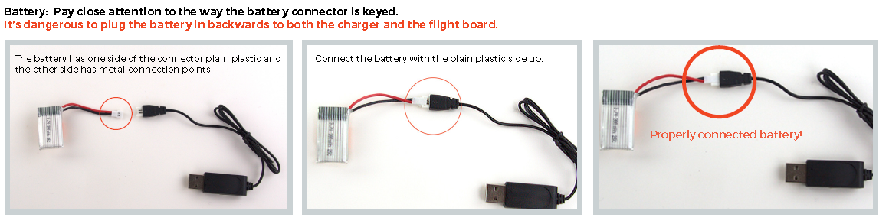

Procedure
Student will be provided with a step by step guide. But they will not be referring to this guide while making the drones. The step guide will be a reference if they missed a step. Instructure has to make sure all students follow him/her step by step and don’t start making the drone by themselves. This is tricky. I will provide clear instructions
Alright everyone. The fun parts starts !! today we will be building a Quadcopter. Can anyone tell me how many legs will a quadcopter have?? < take one/two answers> wow!! Very good. We will be building a quadcopter together.
You are two of you in each team and I trust you will both share the work and make the drone together. Team work is important and it is important that you talk to each other about which step your team is on. Remember the aim is to understand the process and understand the role of each part and not to be the first one to complete the drone. I want you all to pay close attention to the steps because you will be building a drone of your own tomorrow without any instructions!!
So.. I will be displaying the steps here on the slides. There are 12 steps in total and we all will follow each step one by one and together as a class. You will first see the instruction on the slide…you will then watch me follow the instructions and then do it yourself. It is important that you watch me and don’t rush ahead.
The instructor will have the instructions put up on the slides. All the students must follow the instructor step by step

Building the foundation of flying
Wow class.. I see so many drones already completed. We have covered half of the work but the second half, the actual flying, is next. Flying can be complicated at first but really really fun when you get it. Before we start flying I want you all to keep your ready drones in a corner and bring your RC controllers in front of you.
Now let me tell you the very basic flying concepts. There are some terms to get you started:
Thrust: This creates a force to lift your plane up
Pitch: Creates a torque that tilts the nose of your airframe either up towards the sky or down towards the ground
Roll: creates a torque that tilts your airframe side to side. Imagine wings on airplane. They ca tilt back and forth towards the ground or towards the sky.
Yaw: Creates a torque that spins your airframe while remaining flat in the sky with no tilting either forward, backward or side to side.
Flying takes practice to master. If you’re new to being a pilot, be patient with yourself as you learn, flying Flying a quadcopter is not like flying a toy that has one joystick. Flying multirotors are much more involved. Stick with it, you’ll get it!
Here is a video to help you visualise it : https://www.youtube.com/watch?v=YfRnNOQnJzE

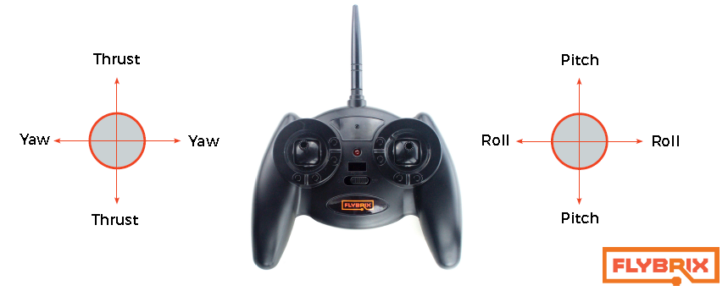

Use the below instructions to explain if need be:
  - There are 3 things you need to do to with your controller to fly. Pairing it to the flight control board - that ensures the two pieces of equipment are “talking”. Arming, which means props are able to spin. And finally disarming – stopping props from spinning.
Once you’re paired, there are two modes: idle and armed. To arm the airframe, make sure the left joystick, the throttle, is all the way down (pointing away from the antenna on the controller). Press in the right joystick like a button. Once armed successfully, the LEDs change to blinking blue. You’ll notice the blinking goes into “airplane mode”. That means the motors will start to spin when you increase the throttle. After you’ve successfully paired the first time to your controller, arming and disarming are the only steps you need to do to fly from now on.
  - At this point, you’re ready to fly. There’s a bit of a delay for the controller to activate the motors. You’ll be able to notice the blinking blue lights change pattern subtly when the flight control board is armed.
  - As you increase the throttle (left joystick moving it up toward the controller antenna) the motors will start to spin. From there, you can increase the throttle more and get into the air!
  - DISARMING: To stop the motors from spinning, let’s say you happen to crash (yes, everyone does)! Push in the right joystick like a button, same way you did to arm the controller. That stops the motors from spinning immediately. Now you’re back in idle mode. It’s important to stop your motors from spinning as quickly as you can after a crash. If the motors are stuck.

Demo the flying principals
- Students will fly the newly build drones using their RC controllers. The instructor will be touring the class at this point and helping student with initial flying instructions.
- Based upon the time in hand, the instructor can show the class a demo in flying and the stunts performed in the class earlier.

Wrap-up

Repeat what was done in class today
The instructor can encourage students to answer questions based on the class today as a way of repetition of the concepts.
- What is a drone?
- How many of you were able to fly your drones successfully?
- How many of you used the minifig and windshield on your drones? Was It different?
- What can you tell me about the propellers on the drones? What is the need for two different types?
- How many types of motors we used? Why?
- Can I make a drone with 3 arms?? or 5 arms?? Why or why not?

Disassembly time & Exit
Students exit tickets from the class will be there neatly disassembled, counted and packed kits. Students will be consciously/subconsciously going thru the steps again while disassembling the drone.

Okay class!! before we leave for today I want you to neatly disassemble your drones. I want you all to count and keep each part back in the box how you found them. Remember you will be using the same boxes tomorrow to build your own drones so you don’t want to lose any part.
Now after you have done that I want you all to keep the boxes with you for now and submit your boxes to me before leaving.

Agenda for tomorrow
Alright class!!. It was amazing working with you all today. Tomorrow will be a little different. You all will use your learnings from today to build and fly a drone yourself tomorrow. I will be here to supervise. We will also play a few games tomorrow with our drones.
I want to leave you all with a video of what all can be done with these drones. I want you all to watch it and start thinking about what will you make tomorrow.
Play : https://www.youtube.com/watch?v=92OAR_MaFIQ
There a bunch of stuff online about what can be done with these kits. Go get inspired and come in tomorrow with amazing ideas. I can’t wait to see what you all come up with tomorrow!!!

Lesson Background for Teachers

Suggested Real-World STEM Connections
- List possible related Role Models in STEM (with details and links to more reading). Give suggestions for examples of scientists/engineers who are from underrepresented groups in STEM in related careers.
- List related real-world engineering problems and examples

Lesson Variations and Options
Include descriptions of alternative methods or ways to present things.

Explanation
Describe the background concepts and explanations behind the lesson. This can be more in depth than a teacher/instructor would actually share with students.

Key Concepts and Vocabulary
- Word 1: Grade Appropriate Definition
- Word 2: Grade Appropriate Definition

Safety Notes
- Safety instruction

